**Instructions for Adding a New GIGA Contact for Outlook 2007**

First open the email then double click on the contact icon.

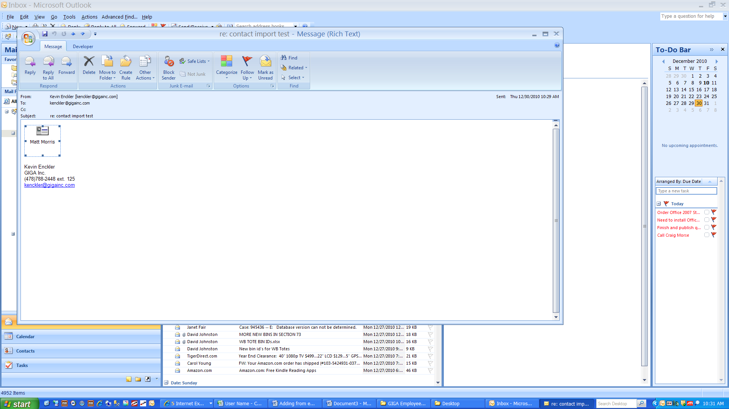

After the contact information page opens, click the Windows icon

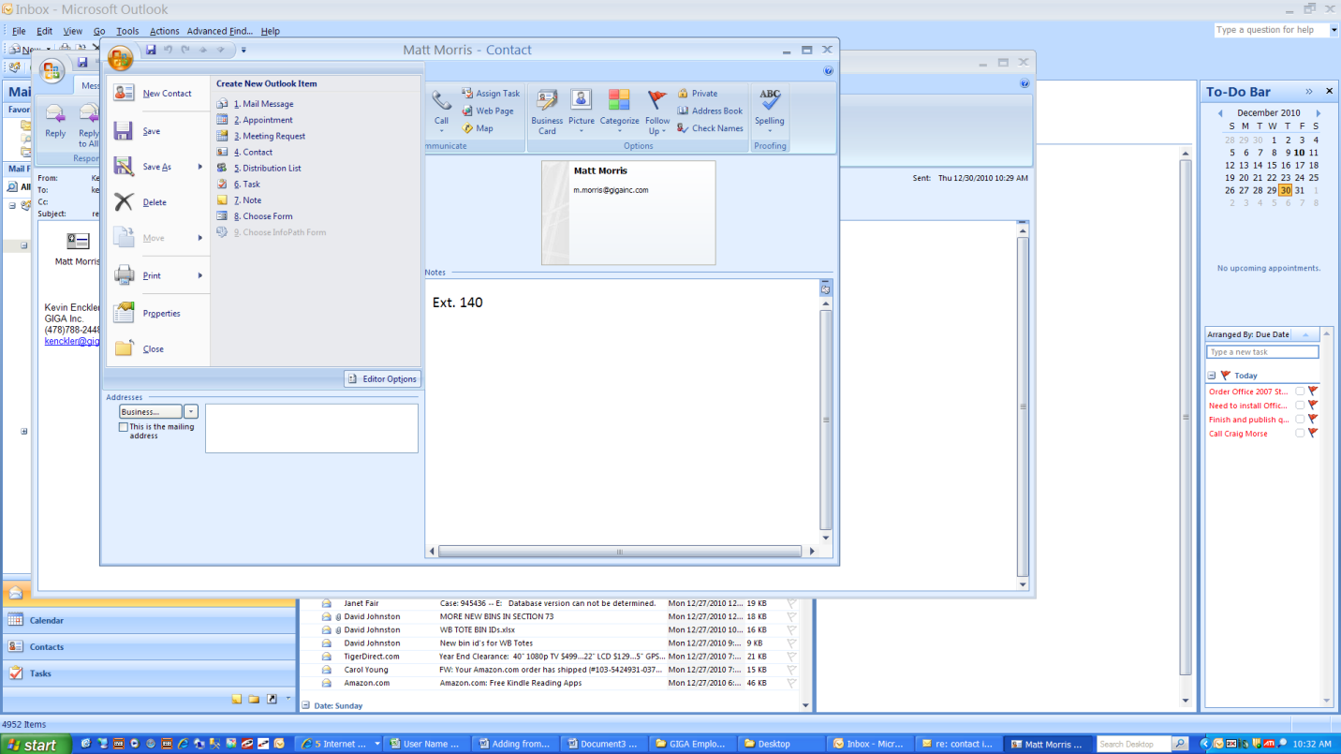

Select move and then Copy to Folder

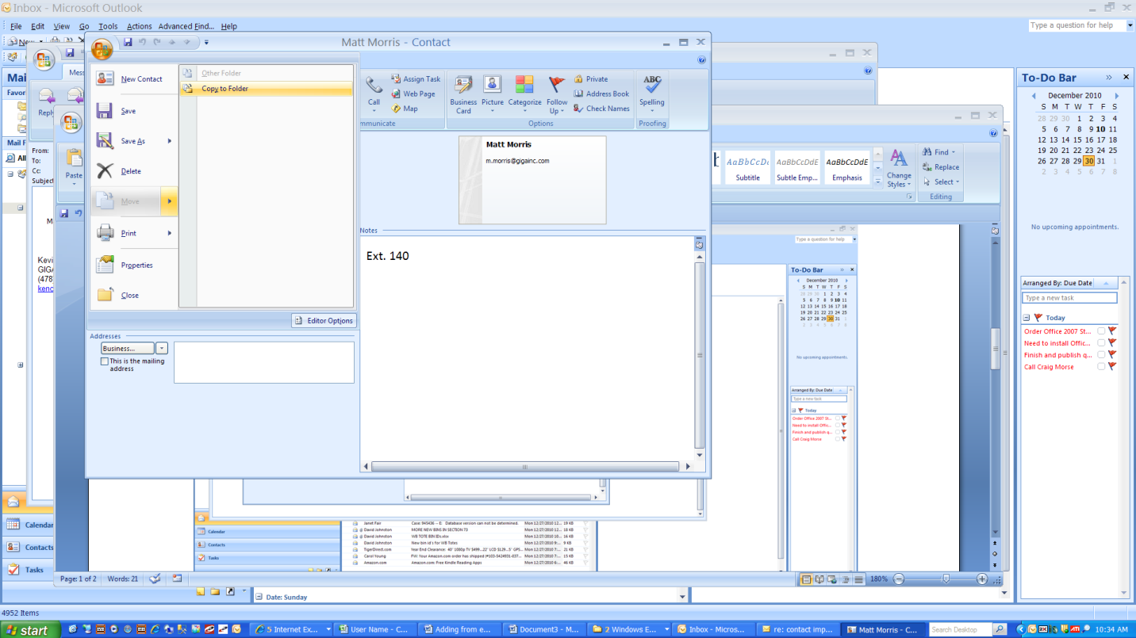

Select GIGA Employees and then click OK

